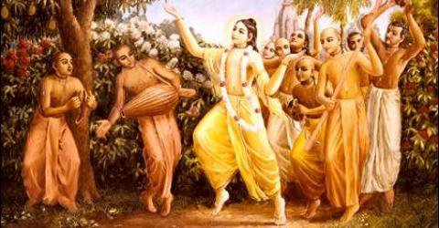

March 2011 Edition
www.soldiersofgodhead.yolasite.com
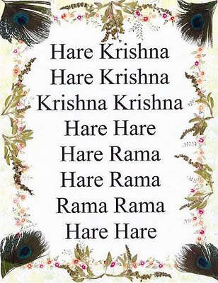
Contents
Sr.no Topic Page no.
- Book distribution 5

- The Parampara System 9

- The Bonafied Spiritual Master 13

- Tulsi devi cures devotee’s cancer 17

- Mukunda Goswami’s “Miracle on Second Avenue” Set for June Realease 26

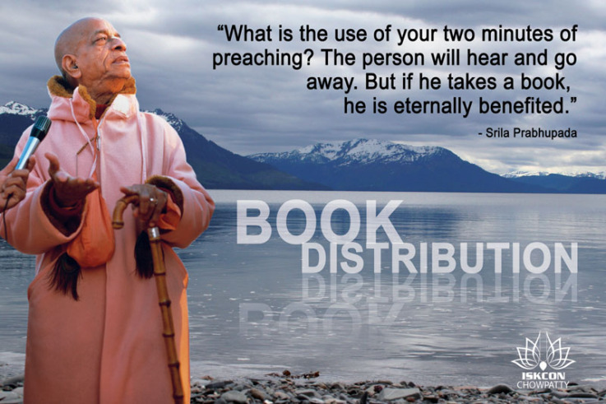
- Book Distribution
The most priceless gift that Srila Prabhupada has given to human society is his books. Even if one may have little or no knowledge about the complex Indian religious customs, one can fulfill the purpose of all religious customs and traditions simply by reading Srila Prabhupada’s books and following His instructions.
Srila Bhaktisiddhanta Sarasvati Thakur Maharaj Prabhupada, the spiritual master of Srila Prabhupada recognized the importance of using modern technological advancements for spreading Krishna Consciousness. He instructed Srila Prabhupada that whenever He gets money He must print books! Before coming to the United States in 1965, Srila Prabhupada had completed translations and commentaries on three volumes of the monumental devotional classic-Srimad Bhagavatam. The then prime minister of India- Sri Lal Bahadur Shastri lauded this accomplishment and Srila Prahupada’s books were placed in public libraries across India. Since His arrival in the U.S in 1965 till His disappearance in 1977, Srila Prabhupada wrote more than 80 volumes of translations and commentaries on books like Srimad Bhagavad Gita, Srimad Bhagavatam, Bhakti Rasamrit Sindhu (The Nectar of Devotion), Sri Upadeshamrita (The Nectar of Instruction), Brahma Samhita and much more.
In all of His books, one gets the original Sanskrit verses, their English transliterations, English equivalents, translation and a detailed verse by verse commentary. This standard is followed in all of Srila Prabhupada’s books. This systematic manner of presentation makes these books authoritative and also standard text books on the science of self-realization. At the heart of His books are His nectarous commentaries where He not only simplifies the meaning of the particular verse or text but also ensures that there is no deviation from the true meaning of the text. Srila Prabhupada ensured that He clearly explained every verse so that there is little or no room for misinterpretations. Also, one finds references to other scriptures and instructions of other Vaishnava Acharyas in the commentaries and this is what makes His commentaries more authoritative.
His books are a source of endless knowledge, inspiration and bliss. If you are seeking any of the above, then Srila Prabhupada’s books are where your search ends. The sole purpose behind every book is to make the reader understand his relation to god and the process of realizing this relationship which is Krishna Consciousness. In order to help the living entities overcome their sufferings and miseries in the material world and to bring them to the lotus feet of Lord Sri Krishna, Srila Prabhupada strongly encouraged His disciples to distribute His books. Book distribution has thus been integral to ISKCON since its foundation. Prabhupada instructed that if you give lectures, people will hear and go away. But if you give them a book, it stays with them and they are eternally benefitted.
Following the instructions of Srila Prabhupada, His disciples and followers take every effort to spread the message of Lord Krishna that is contained in Srila Prabhupada’s books. Book distributions are organized by ISKCON temples around the world and it is as significant as chanting the holy names of Lord Krishna and delivering discourses. One can distribute books even in his individual capacity by gifting books like ‘Bhagavad Gita As It Is’ to friends or family members. This is indeed the most valuable gift that you can ever get or give someone, because not every gift helps you go back home, back to Godhead.
Hare Krishna!
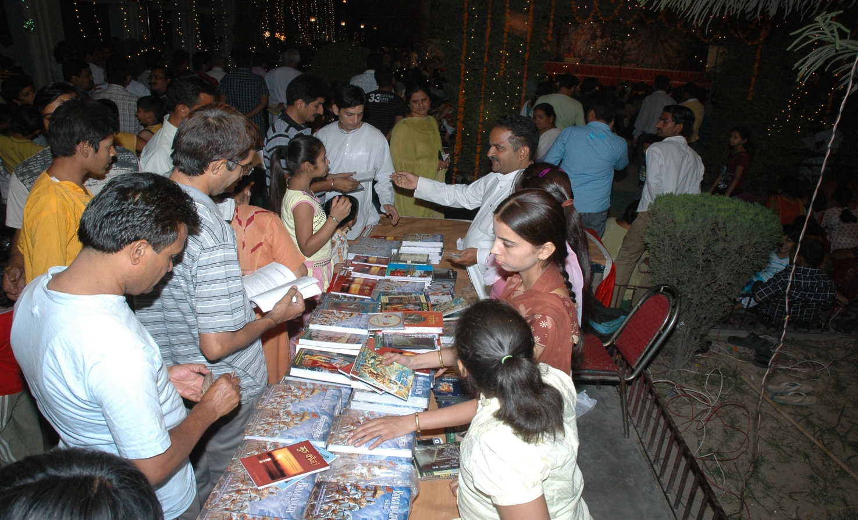
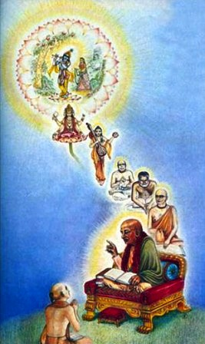
Srila Prabhupada and His disciples belong to the disciplic succession that was initiated by Lord Krishna Himself.

- The Parampara System.
The Parampara System refers to a succession of spiritual masters and their disciples. It is also referred to as Guru-Shishya Parampara. In the Parampara System, the knowledge of the Absolute Truth- Lord Sri Krishna (Krishna Consciousness) is transmitted by a spiritual master belonging to the disciplic succession to his/her disciple. The disciple transmits this transcendental knowledge to his/her disciples and so on. In this manner a chain of spiritual masters and their disciples is formed and this is referred to as the Parampara System or a disciplic succession.
Srila Prabhupada belonged to the Brahma Sampradaya (the disciplic succession beginning from Brahma-the creator of the material universe) of the Vaishnava sect of Hinduism. Lord Brahma was the disciple of Lord Krishna Himself. Hence Lord Krishna has initiated the Brahma Sampradaya. Lord Brahma passed the transcendental knowledge received from Lord Krishna to His son Narada muni, who in turn transmitted it to His disciple Maharishi Ved Vyasa. In this manner by passing from Spiritual Master to disciple, the transcendental knowledge of Krishna Consciousness came to Srila Prabhupada and in order to fulfill the desire of His Spiritual Master (Srila Bhaktisiddhanta Sarasvati Thakur) He brought the knowledge of Krishna Consciousness to the western world and broadcasted it all over the world, thus making the Hare Krishna Movement a global phenomenon.
THE DISCIPLIC SUCCESSION
1. Krsna 17. Brahmanya Tirtha
2. Brahma 18. Vyasa Tirtha
3. Narada 19. Laksmipati
4. Vyasa 20. Madhavendra Puri
5. Madhva 21. Isvara Puri, (Nityananda, Advaita)
6. Padmanabha 22. Lord Caitanya
7. Nrhari 23. Rupa, (Svarupa, Sanatana)
8. Madhava 24. Raghunatha, Jiva
9. Aksobhya 25. Krsnadasa
10. Jaya Tirtha 26. Narottama
11. Jnanasindhu 27. Visvanatha
12. Dayanidhi 28. (Baladeva) Jagannatha
13. Vidyanidhi 29. Bhaktivinoda
14. Rajendra 30. Gaurakisora
15. Jayadharma 31. Bhaktisiddhanta Sarasvati
16. Purusottama 32. His Divine Grace A. C.
Bhaktivedanta Swami Prabhupada

The spiritual masters belonging to this disciplic succession are the true authorities on scriptural injunctions and the authorized commentators on scriptures. Hence if one is seeking true knowledge about the self, the distinction between spirit and matter, god and the path to perfection and answers to other spiritual inquiries, one must approach a bonafied spiritual master belonging to the disciplic succession and must carefully avoid the commentaries of unauthorized persons or people with a poor fund of knowledge of Lord Krishna since such people are not aware of reality, they are not engaged in pure devotional service and neither do they follow any regulative principles in life. They tend to make unauthorized commentaries by saying that this and this is stated in the Gita. But they fail to quote the verse or the chapter of the Gita where this and this is mentioned or they misinterpret the scriptural injunctions in order to fool the innocent public. Hence an intelligent person would take every possible effort to avoid the commentaries of unauthorized commentators. We must approach the bonafied spiritual masters belonging to the Parampara System and inquire from them about Krishna Consciousness. This shall help us to fulfill the purpose of the human form of life and go back home, back to Godhead.
Hare Krishna!

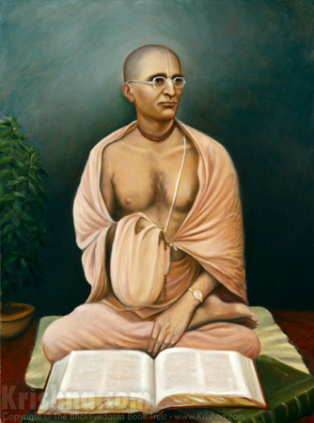
Srila Bhaktisiddhanta Sarasvati Thakur Maharaj Prabhupada.
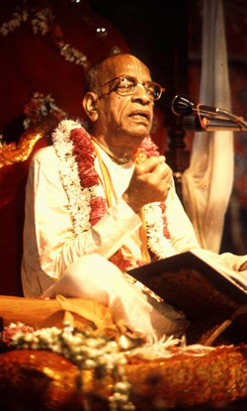
His Divine Grace A.C. Bhaktivedanta Swami Prabhupada
- The Bonafied Spiritual Master.
The spiritual masters belonging to the parampara system or the disciplic succession cited above are said to be the bonafied spiritual masters since they belong to a disciplic succession that was initiated by Lord Krishna Himself and secondly, they have received their knowledge and instructions from an authorized and recognized source. Hence they are the bonafied spiritual masters and anyone who is seeking knowledge or desires to serve the Lord, must accept a bonafied spiritual master as his/her Guru and must serve his/her Guru as a representative of Lord Krishna and must seek knowledge of the absolute truth. This is the Vedic way of receiving knowledge unlike modern day mundane education.
Today, there are many swamis, yogis, gurus etc around the globe. Most of them have just disguised themselves as sanyasis or yogis and are bluffing the innocent public at large. They have mundane followers who preach about demigod worship (worshipping planets, natural forces, other gods and goddesses) and they think of Lord Krishna as a mere incarnation of Lord Vishnu who is just the maintainer of the material world and nothing more according to them. There are others who are teaching various “yogic exercises” and are teaching people how to live a happy materialistic life in this material world. There is another class of bogus gurus called ‘astrologers’ who recommend worship of planets and wearing certain precious stones for pleasing certain planets and are averse to worshiping Krishna. The above listed class of gurus and yogis are called ‘Mayavadis’. These ‘Mayavadis’ have little or no scriptural knowledge but they do not hesitate to make false statements and unauthorized commentaries on scriptural injunctions. The one who is seeking true knowledge and perfection must be careful to avoid such bogus gurus and their missions and movements no matter whatever be their following or popularity.
A bonafied spiritual master is one who :-
- Belongs to the disciplic succession (parampara system)
- Has received knowledge from an authorized and recognized Vaishnava Acharya.
- Preaches nothing but pure devotional service to Lord Krishna.
- Who promotes chanting of Hare Krishna Maha mantra.
- Who abides by the four regulative principles of no meat eating, no intoxication, no illicit sex and no gambling.
- Must not be an impersonalist.
- Chants the names and glories of Lord Krishna and
- Who has accepted whole heartedly on the basis of scriptural injunctions, Krishna to be the Supreme Personality of Godhead.
Anyone seeking a Guru must search for these qualities in the preacher. If he/she is preaching anything else or is not fulfilling all above conditions, then he/she is not a bonafied spiritual master and must not be accepted as a Guru.
The spiritual master is the link between the disciple and Krishna. Hence, we must be careful while approaching a devotee just to make sure that he/she is a pure devotee of Lord Krishna and is fulfilling all the above conditions. When one finds a bonafied spiritual master and accepts him as his/her Guru, then he/she must serve his/her Guru as though he is Krishna in the form of his/her Guru. The spiritual master is the representative of Krishna and must be served accordingly. In return, the spiritual master compassionately transmits the knowledge of Krishna Consciousness to his/her desciples and helps them make steady progress in devotional life.
Srila Bhaktisiddhanta Sarasvati Goswami Maharaj Prabhupada instructed His disciple- Srila Prabhupada to take the knowledge of Krishna Consciousness to the western world and to broadcast it all over the world. Just to fulfill the desire of His spiritual master, Srila Prabhupada came to the west with little or no resources at the age of 70 in 1965 and after a year of struggle established ISKCON in July 1966 to promote Krishna Consciousness all over the world. This is the sincerity that a disciple should have towards his/her spiritual master. By serving the lotus feet of one’s Guru one can be certain that he/she is pleasing Krishna, because when a pure devotee of the Lord is satisfied, the Supreme Lord is also satisfied.
Hare Krishna!

- Tulasi Devi Cures Devotee’s Cancer
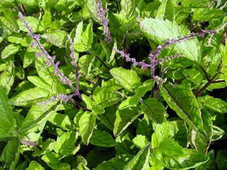
Today, at 69 years old, Chaitanya Prema Dasa is a robust, healthy devotee, visiting the Potomac, Maryland ISKCON temple every Sunday and working at the Pentagon, where he has served for twenty-five years in the Department of the Defense Inspector General. He keeps a small altar with Srila Prabhupada and a large, beautiful picture of Lord Krishna in his office, so that his boss and co-workers see the Lord every time they have meetings there.
Seeing him, you would never guess that back in 1997, at age 55, Chaitanya Prema was diagnosed with Non-Hodgkin’s lymphoma—or blood cancer—that had already reached stage four.The disease spread to his bone marrow, liver, spleen, and lymph nodes. His white blood cell count was high. “The only thing we could do was to pray nonstop,” says his daughter Jahnavi Dasi, who is now doing her PhD in microbiology and holds weekly Krishna conscious programs at the University of Maryland. “I was so worried, I couldn't let go of my beads. I chanted all the time because I was extremely scared.”
Chaitanya Prema’s doctors wanted him to undergo chemotherapy, but Jahnavi was apprehensive. She knew that radiation treatment not only killed the cancer cells, but also burned, scarred and damaged healthy cells in the bone marrow and gastro-intestinal tract, and could cause tissue and organ damage. They could even destroy our immune system’s defence cells, known as Natural Killer Cells. In fact in the past, two of her family’s friends had gotten chemotherapy for their cancer, seen remission initially, and then died two years later when their cancer returned more aggressively than ever before.
Jahnavi asked the doctors if, instead of doing chemotherapy, they would let her try to boost her father’s immune system by natural means to fight the cancer. She had beeen inspired by the movie Lorenzo's Oil, a true story about parents who were determined to save their son from an incurable brain disease. She felt that there must be powerful medicines out there that had not yet been discovered or become mainstream.
“I’ll monitor his blood counts the entire time,” she said. “And we’ll always have chemo to fall back on.” All of her father’s doctors—the oncologist, the surgeon, and primary care physician—were upset with her, and told her she was making a big mistake. But Jahnavi felt sure there was a way. Then, on the holy night of Gaura Purnima 1998, Jahnavi dreamt that she was in the Potomac ISKCON temple, looking into a miscroscope. Through it, she saw Tulasi Devi, the personification of the famous sacred plant, telling her father’s Natural Killer Cells to eat the cancer. When she straightened up, she saw Srila Bhaktivinode Thakura, the spiritual grandfather of ISKCON’s founder Srila Prabhupada. “Don’t take your spiritual dreams lightly,” he said. “Tulasi Devi is the cure.”
As soon as Jahnavi woke up, the tightness in her throat and the fear in the pit of her stomach that had been there for so long faded away. Now she knew what to do. Jahnavi began to research Tulasi, also known as holy basil, or by her botanical name Ocimum sanctum. She found and read many studies from around the world explaining that Tulasi (as well as turmeric) was very powerful and rich in antioxidants that kill cancer. She also read that the sacred plant contained a phytonutrient called ursolic acid, which has been found to cause the programmed cell death of human leukemia cells. This she was excited by, since her father’s cancer, like leukemia, was blood-related. The studies she read were done by major Universities and published in prestigious medical journals. There was a November 2006 study done at the Center for Cancer Biology in Texas Tech University Health Sciences Center; a 2009 study done in Texas and published in the International Journal of Oncology; an October 2009 study conducted at the College of Oriental Medicine in Seoul, South Korea; and a June 2010 study published in the medical journal Food and Chemical Toxicology.
They all showed how Tulasi causes cancer cells to self-destruct, and repairs damaged DNA by activating MGMT repair protein. They also proved how holy basil is radioprotective, and increases the activity of Natural Killer Cells. Jahnavi contacted devotees in Hawaii, who FedExed her large boxes full of Tulasi Manjari garlands offered to the Deities. It wasn’t unusual for them to have giant Tulasi plants growing everywhere on their property, or to be making such large quantities of Manjari garlands—the same is true for many temples located in warm climates. “I began to get my father to eat several Tulasi leaves a day, and then to munch on the Tulasi Manjari garlands,” Jahnavi says. “I also mixed the dried Tulasi leaves with honey. He loved it!”
Along with Tulasi, Jahnavi also added many natural foods and supplements to her father’s diet to help boost his immune system and Natural Killer Cells to fight the cancer.
“I started giving him carrot juice, wheatgrass or spinach green juice daily, which are all high in phytonutrients,” she says. “We switched to a low fat diet, with whole grains, unrefined sweeteners, spring water, and organic foods. We also made sure to avoid fried food, artificial colors, flavors, and preservatives.”
Jahnavi also gave her father ginseng, and ten grams of Vitamin C a day. “Nobel Prize winner Dr. Linus Pauling made many studies showing how vitamin C is one of the key nutrients that are needed to give the patient's body cancer-fighting ability,” she says. “He describes how when he gave one patient with an inoperable brain tumor ten grams of vitamin C every day, her tumor shrank in eight months. This daily dose of Vitamin C was also found to significantly increase the life span and enhance the quality of life in 100 terminal cancer patients.”
In addition to the Vitamin C, Jahnavi started giving her father 500 mg of Vitamin B3 three times a day and 25,000 IU daily of Beta Carotene and Vitamin E, as well as B complex, Selenium Zinc, and Coenzyme Q10.
Adding to his treatment, Chaitanya Prema also absorbed himself in chanting the Hare Krishna maha-mantra and meditating on God. Within only six months, he showed marked progress. Eight months after starting his new regimen, repeated CT scans and blood work demonstrated that his body no longer showed any signs of cancer.
“It was all by Lord Krishna and Srila Prabhupada's mercy,” Jahnavi says. “Tulasi Devi is our hero!”
She explains that all types of cancer grow due to deficiencies in the immune system, and that the way to defeat cancer is to strengthen the immune system.
“The immune system can be compared to the police department, and cancer cells of any kind to criminals,” she says. “If we have weak police officers that are thin and malnourished, then how will they fight the criminals? But if we have lots of strong, powerful policemen (Natural Killer Cells) that outnumber the bad guys (cancer cells), then the policemen will defeat them. No more criminals—no more cancer.”
Following Jahnavi’s footsteps, we can boost our immune systems by taking vitamins and nourishing foods such as fresh fruit like grapes, blueberries, acai berries and pomegranate, which are are loaded with phytonutrients that have anticancer properties. Eliminating toxic overload on our immune systems is also a must, including unnecessary over-the-counter drugs, chemical additives, artificial colors, and MSG in foods. Keeping away from second-hand smoke, pollution, and intoxicants also helps to relieve the burden on your “police officers” so that they can be at their optimal strength.
Keeping a positive mindset helps, too. Jahnavi believes in the therapeutic power of hope, and feels that enhanced hope has a considerable positive impact on the immune system and can contribute to a much more favorable outcome in the fight against cancer. “Our immune system is there for a purpose,” Jahnavi says. “It's designed to kill cancer before cancer can spread. So let’s give it a boost.”
And of course, one of the biggest boost-givers is Tulasi Devi, the sacred plant and beloved servant of Lord Krishna.
“It’s been fourteen years now since my father’s cancer went into remission, and to this day, he’s still cancer-free—and he still takes his Tulasi leaves every day!” Jahnavi says. “We pray that our story can help others with cancer, too. Remember, there is hope. After all, anything is possible by the power of Lord Krishna, and his miraculous servant Tulasi Devi.”
Courtesy: www.iskconnews.com

- Mukunda Goswami’s “Miracle on Second Avenue” Set for June Release
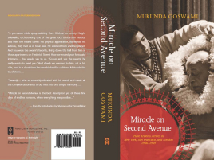
ISKCON guru Mukunda Goswami’s long-awaited memoir of the early days of the Hare Krishna Movement in New York, San Francisco, and London—entitled Miracle on Second Avenue—was ceremonially “offered” to the Deities of Sri-Sri Pancha-Tattva at ISKCON’s headquarters in Mayapur, West Bengal on February 23rd.
Although the official release date isn’t until June, advance copies of the book are available at publisher Torchlight’s booth at Mayapura’s Gaura Purnima Festival, which runs until March 21st.
Mukunda Goswami’s memoir has always been highly anticipated, since he was in the very first group of devotees to be initiated by Srila Prabhupada in 1966, and has served Prabhupada’s movement faithfully since. His memories were always expected to give us a truly special glimpse of the early days of ISKCON. And early word is that they do exactly that.
“Its great reading—personal, intimate, and with many previously unheard details,” said GBC member Anuttama Dasa, reading the book in between ISKCON management meetings in Mayapur. “It’s also expertly written through the eyes of the times rather than as later reflections, which makes it immediate, accessible and insightful.” “Miracle on Second Avenue is the best description yet of those fine days of endless horizons, when everything was possible,” writes Shyamasundar Das Adhikari—a close companion of Mukunda Goswami in those pioneering days—in his introduction to the book.
It was in 1965 that Srila Prabhupada, at seventy years old, arrived in New York City determined to start a worldwide spiritual movement. After a harrowing sea journey on the freighter Jaladuta, where he suffered two heart attacks, he set foot on American soil with nothing but a few cases of books and eight dollars. But there were people who wanted to help. And from a small storefront on Second Avenue in New York’s East Village, the spiritual movement he envisioned miraculously began to take form.
That’s where Mukunda Goswami’s vividly personal and up-close account begins, detailing the the years from 1966 to 1969, and describing the optimism and energy of the early followers of Srila Prabhupada, whom they then affectionately called “the swami.”
Mukunda Goswami takes us to the Bowery where, as Michael Grant, he first helped “the swami” move from a dingy rented loft to a small Lower East Side storefront in Manhattan—thus founding the first Krishna temple in the West.
“Srila Prabhupada was alone in an Artists-in-Residence loft,” he tells ISKCON News. “He was living like a sadhu, modestly and in abject poverty. I joined because I wanted to help him.”
Soon after, on September 8, 1966, Michael and ten other newcomers were initiated as Mukunda, Janaki, Hayagriva, Umapati, Ravindra Svarupa, Raya Rama, Karlapati, Jagannath, Stryadhisa, Satyavrata, and Janardana.
“I remember Srila Prabhupada conducted a fire yajna,” says Mukunda Goswami. “We all had beads, which he asked us to touch to the feet of Lord Chaitanya, whose painting was framed in a makeshift altar in the room.”
Gradually Prabhupada’s number of followers increased, drawing the attention of many icons of the sixties such as poet Allen Ginsberg.
During 1967, the “Summer of Love,” Mukunda and his then-wife Janaki, along with two other couples—Shyamasundara and Malati, and Gurudasa and Yamuna—opened a temple in San Francisco’s Haight-Ashbury neighborhood, the center of the hippie movement, and brought Prabhupada from New York to join them.
There they hosted the Mantra Rock Dance concert, where “the swami” appeared alongside some of the biggest names in rock music, such as Janis Joplin and the Grateful Dead. Thousands chanted along with Srila Prabhupada, and cemented his small movement’s importance to the American counterculture.
In 1967, the same small pioneering group of Mukunda and his friends headed to London. There, they befriended George Harrison and John Lennon of the Beatles. George helped them open a center and produced the Radha Krishna Temple album on the Beatles’ Apple Records. Two singles from the album, Govinda and Hare Krishna Mantra, quickly rose to the top of the British charts, leading to devotees appearing on Top of the Pops and turning Hare Krishna into a household phrase.
It was successes such as these in New York, San Francisco and London that catapulted ISKCON into a worldwide phenomenon. In Miracle on Second Avenue, Mukunda Goswami brings the reader along with him through those magical times—and we feel the intimacy the early followers had with Srila Prabhupada, and experience the movement’s formative years.
Mukunda Goswami says that the 452-page book, which he started writing in 1996 due to popular demand, took him eight years to complete.
“I always hated Marcel Proust’s several-thousand page memoir, Remembrance of Things Past, but this was different—I enjoyed writing about my own past,” he says. “It was exciting, even inspiring. I would get up very early in the morning to write—about 3:00am most of the time. And I wrote most of the book from memory, with the help, of course, of some research and a few interviews.” Despite having had such a prominent hand in the early days of ISKCON, and having remained a faithful servant of Srila Prabhupada through so many years, Mukunda Goswami remains refreshingly unassuming and humble.
“I've tried to adjust to the many changes ISKCON has undergone in 44 years,” he says. “At 68, I just feel lucky to be alive and overjoyed to see that ISKCON is continuing because of the energies of people much younger than me.” He feels that devotees today can learn much from the early days of ISKCON, and from the many senior ISKCON devotees—even those who have passed on—through their recorded talks, living standards, and writings.
But the early ISKCON devotees could have learnt a lot from today’s devotees too, he says: flexibility without compromise, willingness to change, the importance of learning, knowledge and philosophy.As for the advice he has for younger devotees, it’s simple, straightforward, and powerful:“Follow the vows you took at initiation as strictly as possible, read Srila Prabhupada’s books daily, spread Krishna Consciousness somehow, follow ISKCON authorities, and stay in ISKCON,” he says. Miracle on Second Avenue (Hard bound with jacket, 95 photographs, 452 pages) is currently available at ISKCON Mayapur’s Gaura Purnima festival. It will go on sale at ISKCON retailers and Amazon.com in June.
Courtesy: www.iskconnews.com
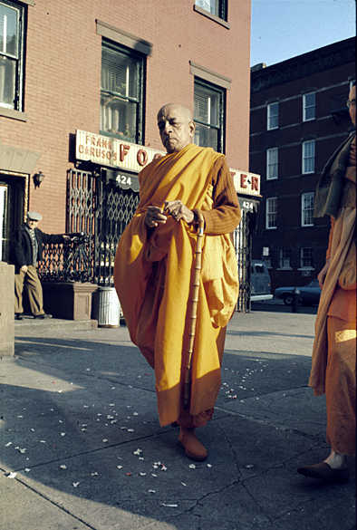
Dedicated to His Divine Grace A.C. Bhaktivedanta Swami Prabhupada, Founder Acharya of the International Society for Krishna Consciousness.

Dedicated to Lord Sri Krishna and Srila Prabhupada.
Written, Edited, Published and Distributed by,
Vinay.D.Chakraborty
My Special Thanks to www.iskconnews.com
For more information visit:-
www.soldiersofgodhead.yolasite.com
Write in your views, suggestions, comments or queries to:
Vinay.chakraborty@yahoo.com

Hare Krishna!

